Indoor real-time position tracking using LoRaWAN devices and Azure Maps

Deployment Instructions

# Clone repo

<https://github.com/Azure-Samples/azuremaps-indoor-realtime-position-tracking>

# Create resource group in Azure Subscription

To isolate all resources associated to this deployment, create a new resource group in the Azure portal.

# Create IoT Central Application

# Add Device (e.g., smart phone)

Go to the IoT Central application URL and add new device.

Select the device that was just created.

Select “Connect”.

Select “QR code”.

On your smartphone, install the “IoT Plug and Play” app.

Go to Settings and Registration and select “Scan QR code”.

Then, scan the QR code from the IoT Central application so that your smart phone gets linked to this IoT Central application.

You should be seeing telemetry now in your IoT Central application.

# Create Azure Web PubSub

Under “Keys”, take a note of the connection string for this service.

# Create Storage Account

Save the value for the connection string under “Access keys” since you will need it later.

Under “Storage browser”, click on “Blob containers”:

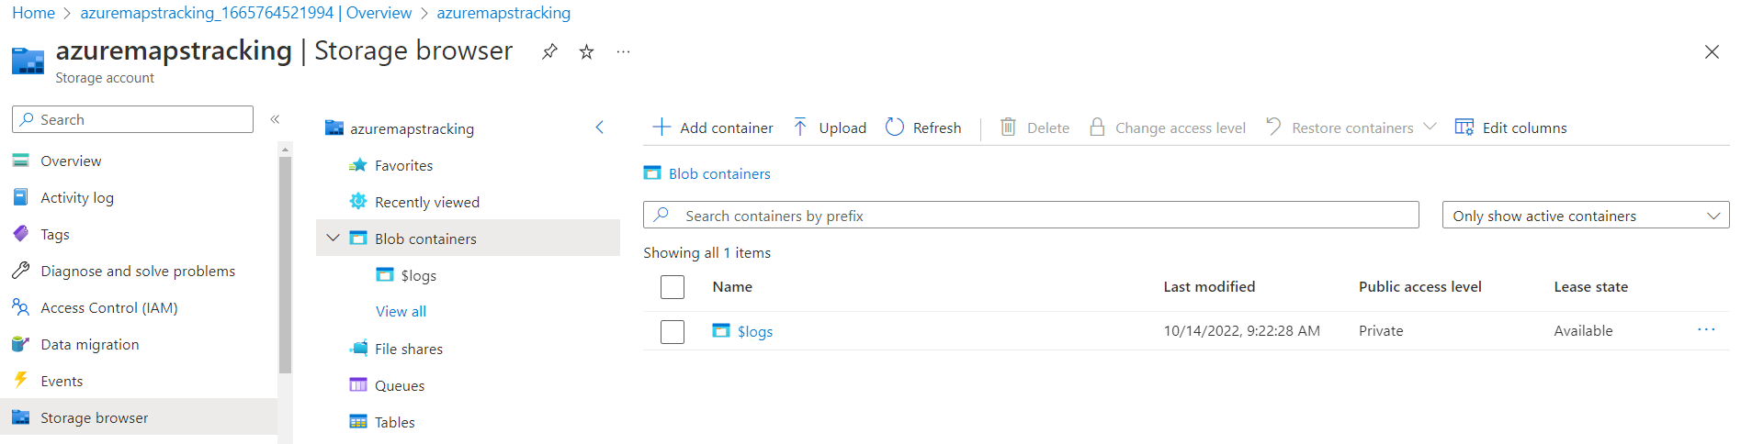

Create a new blob container called “iotclogs” (private):

Create another blob container called “public” with anonymous read access:

Enable CORS:

Install “Azure Storage Explorer”: [<https://azure.microsoft.com/en-us/features/storage-explorer/>](https://azure.microsoft.com/en-us/features/storage-explorer/)

Using Azure Storage Explorer, upload the content of the “public” folder in your repo to the corresponding blob container.

# Create Azure Maps instance

Enable CORS:

Save the primary key Azure Maps, which you can find under “Authentication”.

# Create Azure Function

And make sure you use the same storage account we created previously:

Once the Function App is created, enable CORS:

Then, under “Configuration”, add a new entry for WebPubSubConnectionString with the corresponding value that we saved previously.

Also, under “Configuration”, enable Web sockets:

# Modify Function App

We will modify the Azure Function by deploying the code we cloned from the repo.

Open the following folder using VS Code:

Let’s start with “index.html” in the main folder.

First, replace “<YOUR-BLOB-STORAGE-URL>” with the corresponding value, which you can get from Settings/Endpoints/Blob service in the Azure portal. There should be 6 instances of it that you need to replace in this file.

For example:

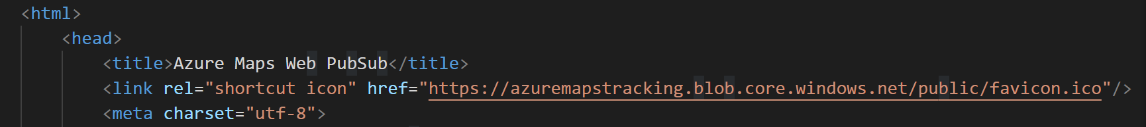

Then, replace “<YOUR-AZURE-MAPS-KEY>” with the map key you had saved previously.

# Deploy Function App to Azure

We now need to deploy each of the functions we have to the Azure Function we created previously. We will do this by right clicking on the corresponding folder and selecting deploy to Function App:

This step will deploy 4 functions to the Function App: index, negotiate, notification, and processdata.

# Export from IoT Central to Webhook

Create a new Data Export component using the following steps:

Click on “New export” and fill out the fields as follows:

Add a new Destination:

And finally add a Transform using the following transformation query:

{

    deviceId: .device.id,

    enqueuedTime: .enqueuedTime,

    telemetry: .telemetry | map({ key: .name, value: .value }) | from_entries,

}

Now you can save this Data Export component.

Once this service is showing “healthy” state, you should be ready to start seeing data points in your map! Just make sure that the IoT Plug and Play application is open in your smartphone.

Just go to the URL that corresponds to the “index” function that you deployed to the Function App:

# Export from IoT Central to Storage

Let’s create a new Data Export destination for processing the logs.

Using the same Data Export component that we created previously, click on create a new destination with the following details:

We’ll use the connection string for the storage account that we saved previously. This will push location history data to iotclogs in blob storage.